|  |  |  |  |  |  |  |
| --- | --- | --- | --- | --- | --- | --- |
| **Company** |  | **Name** |  | **Phone** |  | **E-mail** |
| Company |  | Name |  | Phone |  | E-mail |

**Handling swivel arm of the HSA series**

|  |  |  |  |  |  |  |  |  |  |  |
| --- | --- | --- | --- | --- | --- | --- | --- | --- | --- | --- |
|  | for DSM nutrunner |  | Product line | Select |  | or specific designation | | Nutrunner designation | | |
|  |  |  |  |  |  |  |  |  | | |
|  | for third-party tool |  | Tool weight | Weight | kg |  | Data provided | Reaction torque max. | TQ | Nm |

|  |  |  |  |  |  |  |  |  |  |
| --- | --- | --- | --- | --- | --- | --- | --- | --- | --- |
|  | **Position monitoring** (XY sensor) |  | **PoSys** (Positioning controller) with |  | Profinet |  | Profibus |  | EtherCAT |

|  |  |
| --- | --- |
|  | Connection to DSM control system (System bus) |

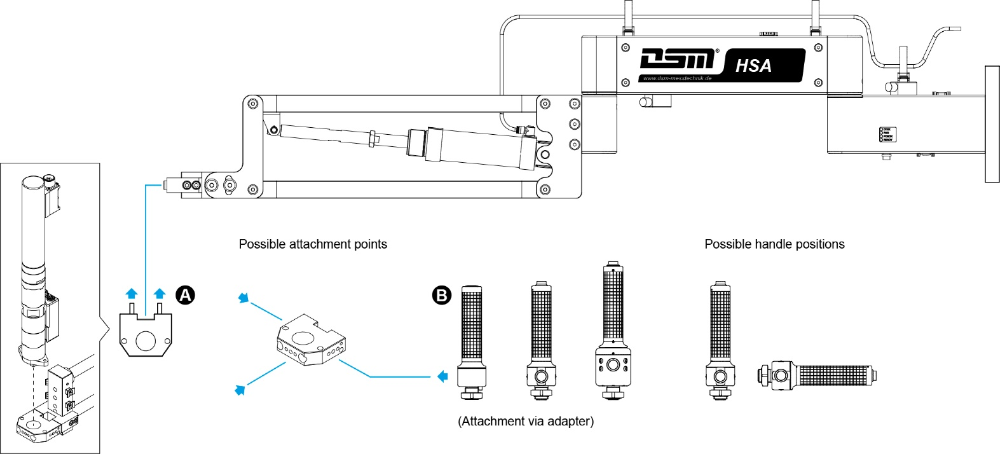

**Equipment options**

|  |  |
| --- | --- |
| **A** | Tool Holder |

|  |  |  |
| --- | --- | --- |
|  |  | Tool holder – compatible to DSM nutrunner |

|  |  |  |  |  |
| --- | --- | --- | --- | --- |
|  |  | Universal tool holder | Ø | mm |

|  |  |  |  |  |
| --- | --- | --- | --- | --- |
|  |  | Custom tool holder | Specification |  |

|  |  |  |
| --- | --- | --- |
| **B** | Handle | Quantity |

|  |  |  |  |
| --- | --- | --- | --- |
|  |  | Standard handle **HG-ESD** | ? |

|  |  |  |  |
| --- | --- | --- | --- |
|  |  | Handle with start button **HG-S-ESD** | ? |

|  |  |  |  |
| --- | --- | --- | --- |
|  |  | Handle with start button, Program switchover **HG-S-PG-ESD** | ? |

|  |  |
| --- | --- |
| **Note** | Click here to enter text. |