Company |  | Name |  | Phone |  | E-mail
Company |  | Name |  | Phone |  | E-mail

Tightening strategy | ☐ | Consider special requirements | ☐ | Data provided | ☐ | Consider installation space / accessibility

Torque | TQ | Nm |  | Tolerance | Tolerance |  | Torque max. | TQ max. | Nm

Angle | AN | ° (deg) |  | Tolerance | Tolerance |  | Tightening time | Time | s |  | Parts | Parts | ☐ | per day | ☐ | per year

Alternative evaluation / switch off | Criterion | Criterion | Value | Unit |  | Tolerance | Tolerance

Execution of measurement technology | ☐ | MDW (with torque sensor) | ☐ | MDW-MD (redundant design TQ) | ☐ | SA (current controlled – w/o sensor)

☐ | Hand-held nutrunner DSH series | ☐ | Pistol grip nutrunner DS-P series | ☐ | Built-in nutrunner DS series

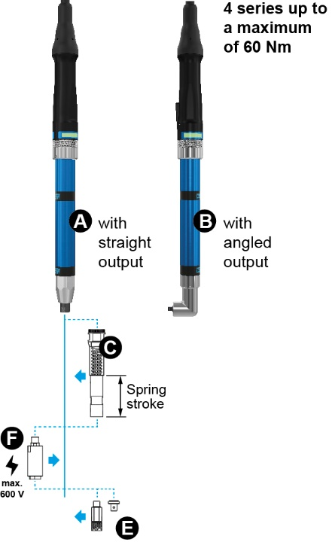 | 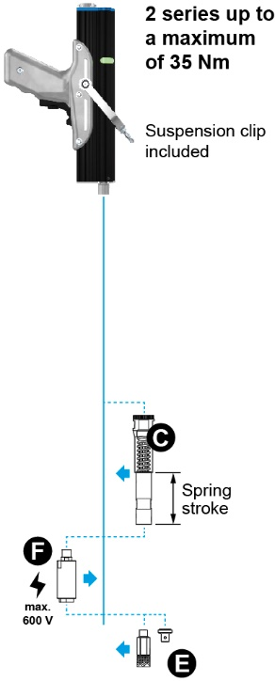 | 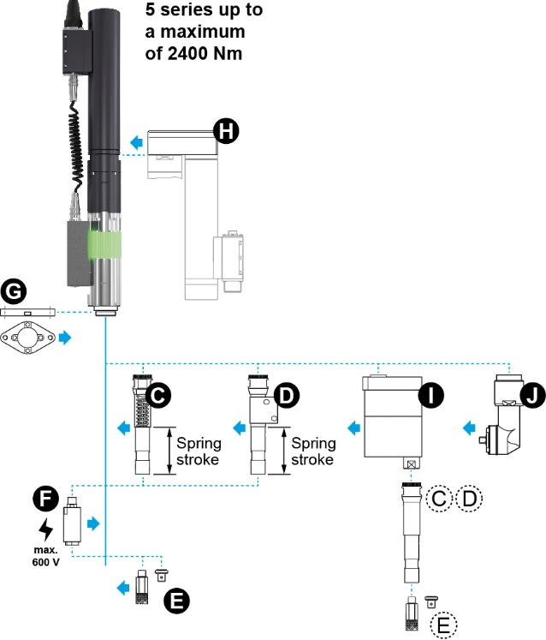

A | ☐ | Design „Straight nutrunner“ | E | Output feature | F | ☐ | Output unit GT (galvanic isolation)

B | ☐ | Design „Angle nutrunner“ |  | ☐ | ↓ Quick-change chuck for bit: | G | ☐ | Mounting flange

 | ☐ | A / B with suspension for mounting |  |  | Bit |  | H | ☐ | Drive offset V2 (side-mounted motor)

C | ☐ | Spring output |  | ☐ | Square drive: | Select |  | I | ☐ | Output offset V1

D | ☐ | Spring output with self-start initiator |  | ☐ | ↓ Special output feature: | J | ☐ | Angle head

 |  | Stroke: | Select |  |  |  | Select

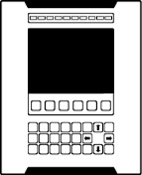 | ☐ | Profinet |  | Extension level | Select |  |  |  | License | Select
 | ☐ | EtherCAT |  | License | Select |  |  |  | License | Select
 | ☐ | Profibus |  | License | Select |  |  |  | License | Select
 | ☐ | Safety function STO (Safe Torque Off) |  |  |  |  | Length of connecting cable |  |  | Select

Note /  Task description | Click here to enter text.

Accessories for workstation equipment
☐ | Handling system |  | ☐ | Tool change box (ToolControl) |  | ☐ | Screw feeding system |  | ☐ | Screw setting unit |  | ☐ | Bit changing machine

